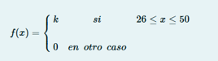

**(50-26)*k = 1**

**24*k = 1**

**K = 1/24**

Punto a)

P(x >43) = (50-43)*1/24 = 0.2917

Punto b)

P(30< x < 45) = (45-30)*1/24 = 0.625

P(41< x < 45) = (45-41)*1/24 = 0.1667

Punto c)

P( x>41/ x < 45)

🡺

🡺 🡺 = 0.2106

P(x < 45) = (45-26)*1/24 = 0.7917